Supporting information
Time evolution of β-lactoglobulin corona formation on gold nanoparticles and impact on allergy
Xiaoning Zhang^{1,}*, Meifeng Li², Yuanping Lv³, Xiaoling Sun¹, Yao Han¹, Xiangzhong Zhao^{1,}* and Xiaowen Huang^{4,}*

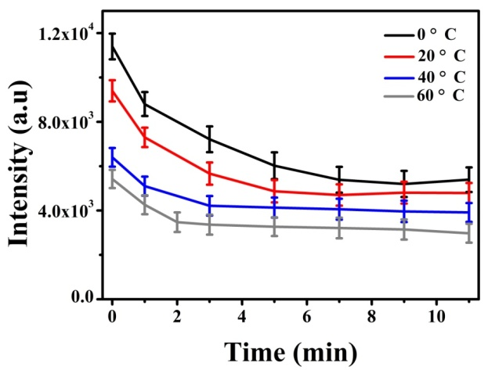
Figure S1 The time evolution of fluorescence intensity after βlg conjugated with AuNPs at different temperature.

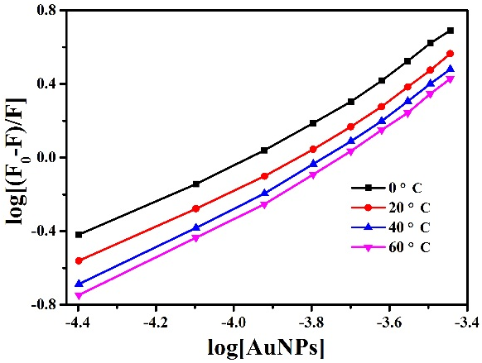
Figure S2 Fluorescence quenching properties of βlg by AuNPs at different temperature.

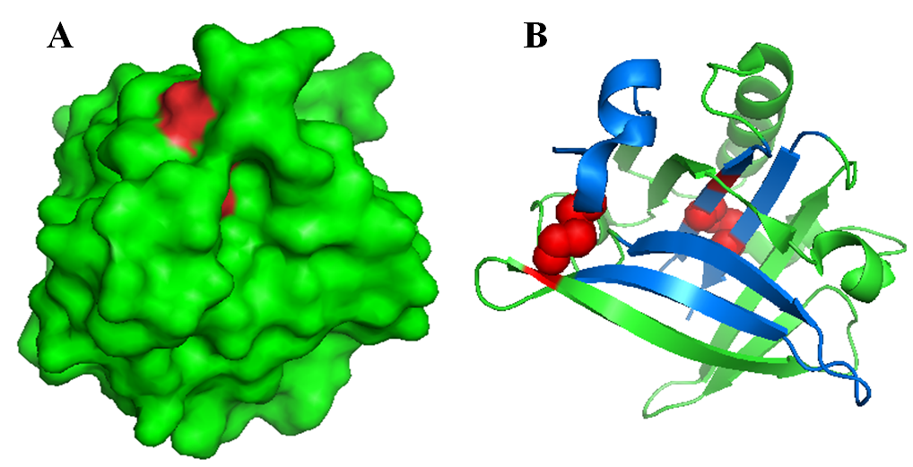
Figure S3 (A) The location of disulfide bridges and cysteine residues in the and marked in red. The Cys66-Cys160 is located on the surface, while, Cys106-Cys119 and free thiol group (Cys121) are located in the core region of the protein. (B) The location of disulfide bridges and cysteine residues and marked in red, the IgE allergenic epitopes located at AA 41-60, 102-124, 149-162 marked in blue.
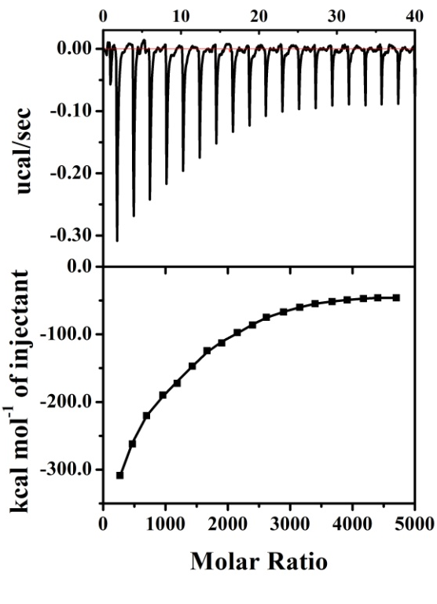
Figure S4 ITC date. The titration of IgE-HRP (30 μM) was titrated into the AuNPs (5×10⁻⁴ μM) at 20 °C. (Upper) Raw data. (Lower) Integrated heats in each injection versus molar ratio of protein to NPs together with a fit using a one site binding model.

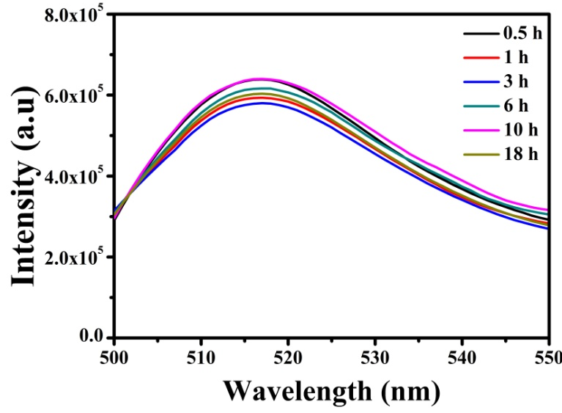
Figure S5 The fluorescence intensity of βlg* on the surface of AuNPs-protein conjugates after added IgE-HRP at different incubation time.

Table S1. The binding parameters of IgE-HRP titrated into AuNPs determined by ITC
 | Stoichiometry  (×10³) | Ka  (×10⁶ M⁻¹) | ΔH  (×10⁶ J M⁻¹) | ΔS  (×10³ J M⁻¹ deg⁻¹)
20°C | 1.9 | 1.1 ± 0.4 | 1.7 ± 0.8 | 5.6

